Neha singh

Node JS

What is Node JS?

Node.js is server-side platform. NodeJs is an open source, cross platform runtime environment for developing server-side network applications. Node. js application are written in JavaScript.

Features:-

* Node.js is ideal for I/O intensive applications.
* Great for prototyping and agile development.
* Superfast and highly scalable.
* Non Blocking asynchronous architecture
* Should not be used for CPU intensive applications

Background:-

* Before Node JS every Browser(IE,Chrome,Firefox) execute the Javascript as per their runtime engine.
* Node JS is created by Ryan Dahl in 2009. He put Chrome V8 engine and embed in C++ program called node js

Architecture:-

Node uses single thread to serve multiple requests and use event queue to manage.



Pros:-

This allows node a ideal for I/O intensive apps. These allow applicatin to highly scalable.

Cons:-

Do not use for CPU intensive apps.

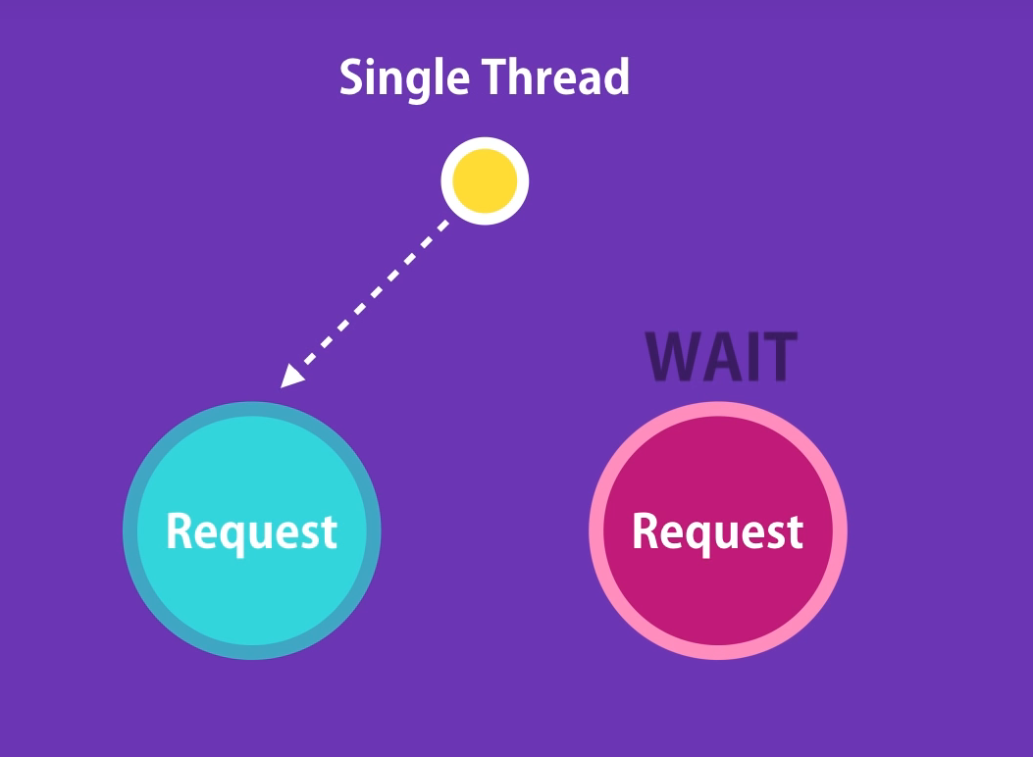

Installation :-

You can download latest version of node JS from <https://nodejs.org/en/download/>

Getting Started with Node JS

1. Check Node Version to ensure it is working. You can use below command.

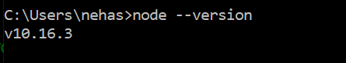

1. Open any of your fav editor e.g: VS Code/ Sublime/Notepad++

And create javascript file with following code:-

function sayHello(name)

{

console.log('Hello ' + name);

}

sayHello('Neha');

Now Open terminal and type

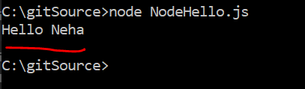

1. Important Node Global objects:-

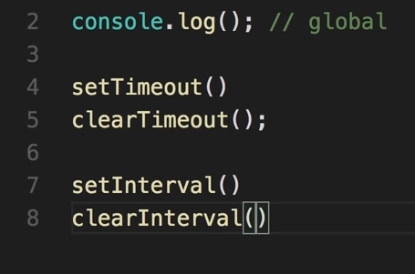

Node Modules System:-

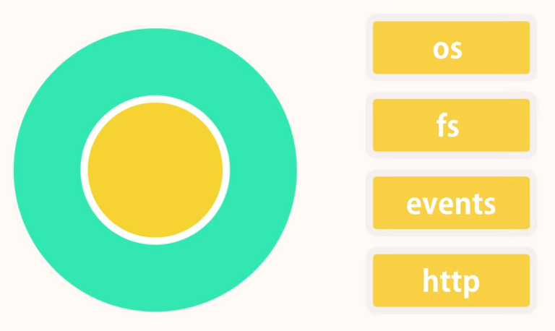

Every .js application/file has atleast one main module.

Node JS Api reference:

* <https://nodejs.org/en/docs/>